- \Operation\Hot air station\Lifter
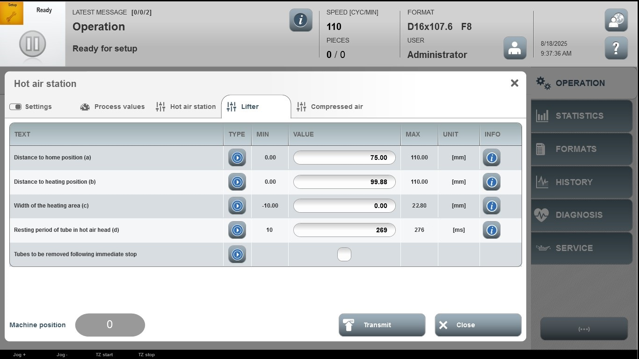

Acceptance criterion | Limits | Pass / Fail: Dev-No. | Date | Initials
Screen matches screenshot | N / A
Distance to home position (a) | 0.00 … 110.00
Distance to heating position (b) | 00.00 … 110.00
Width of the heating arear (c) | -10.00 … 22.80
Resting period of tube in hot-air head (d) | 10 … 276

